**Quiz-Ch09-10**

**Name: _Michael Dandrea_______________________________**

1.     _____ (2 points) In systems that supports virtual memory, ______________.

a.     virtual memory is separated from logical memory

b.     virtual memory is separated from physical memory

c.     physical memory is separated from secondary storage

d.     physical memory is separated from logical memory

2.      (3 points) The ______________________________is the number of entries in the TLB multiplied by the page size. TLB Reach

 3.     (5 points) Please describe Belady’s Anomaly: For some page replacement algorithms, the page-fault rate may increase as the number of allocated frames increases.

4.      (5 points) Please describe Demand Paging: Demand paging is a memory management scheme used to efficiently manage the storage of programs and data in a computers main memory where only the necessary parts of a program are loaded into memory when they are actively used.

5.     (5 points) Please describe COW (Copy On Write). Allows the parent and child processes to initially share the same pages, but when either process modifies a page, a copy of the shared page is created.

6.    (10 points) Given six memory partitions of 300 KB, 600 KB, 350 KB, 200 KB, 750 KB, and 125 KB (in order), how would the first-fit, best-fit, and worst-fit algorithms place processes of size 115 KB, 500 KB, 358 KB, 200 KB, and 375  KB (in order)? Rank the algorithms in terms of how efficiently they use memory.

**Using First-fit**

First-fit means you assign the first available memory that can fit a process to it.

* 115KB will fit into the first partition. So, F1 will have a remaining free space of 185KB (300 - 115).
* 500KB will fit into the second partition. So, F2 will have a remaining free space of 100KB (600 - 500)
* 358KB will fit into the fifth partition. So, F5 will have a remaining free space of 392KB (750 - 358)
* 200KB will fit into the third partition. So, F3 will have a remaining free space of 150KB (350 -200)
* 375KB will fit into the remaining partition of F5. So, F5 will a remaining free space of 17KB (392 - 375)
* **Using Best-fit**
* Best-fit means you assign the best memory available that can fit a process to the process.
* 115KB will best fit into the last partition (F6). So, F6 will now have a free remaining space of 10KB (125 - 115)
* 500KB will best fit into second partition. So, F2 will now have a free remaining space of 100KB (600 - 500)
* 358KB will best fit into the fifth partition. So, F5 will now have a free remaining space of 392KB (750 - 358)
* 200KB will best fit into the fourth partition and it will occupy the entire space with no remaining space (200 - 200 = 0)
* 375KB will best fit into the remaining space of the fifth partition. So, F5 will now have a free space of 17KB (392 - 375)
* **Using Worst-fit**
* Worst-fit means that you assign the largest available memory space to a process.
* 115KB will be fitted into the fifth partition. So, F5 will now have a free remaining space of 635KB (750 - 115)
* 500KB will be fitted also into the remaining space of the fifth partition. So, F5 will now have a free remaining space of 135KB (635 - 500)
* 358KB will be fitted into the second partition. So, F2 will now have a free remaining space of 242KB (600 - 358)
* 200KB will be fitted into the third partition. So, F3 will now have a free remaining space of 150KB (350 - 200)
* 375KB will not be assigned to any available memory space because none of theavailable space can contain the 375KB process.
* Best-fit is the best (it still has free memory space of 777KB and all process is completely assigned) followed by First-fit (which has free space of 777KB but available in smaller partition) and then worst-fit (which has free space of 1152KB but a process cannot be assigned)

 7.  (10 points) Suppose we have the following page accesses:

         1 2 3 4 2 1 3 2 4 3 2 1 1

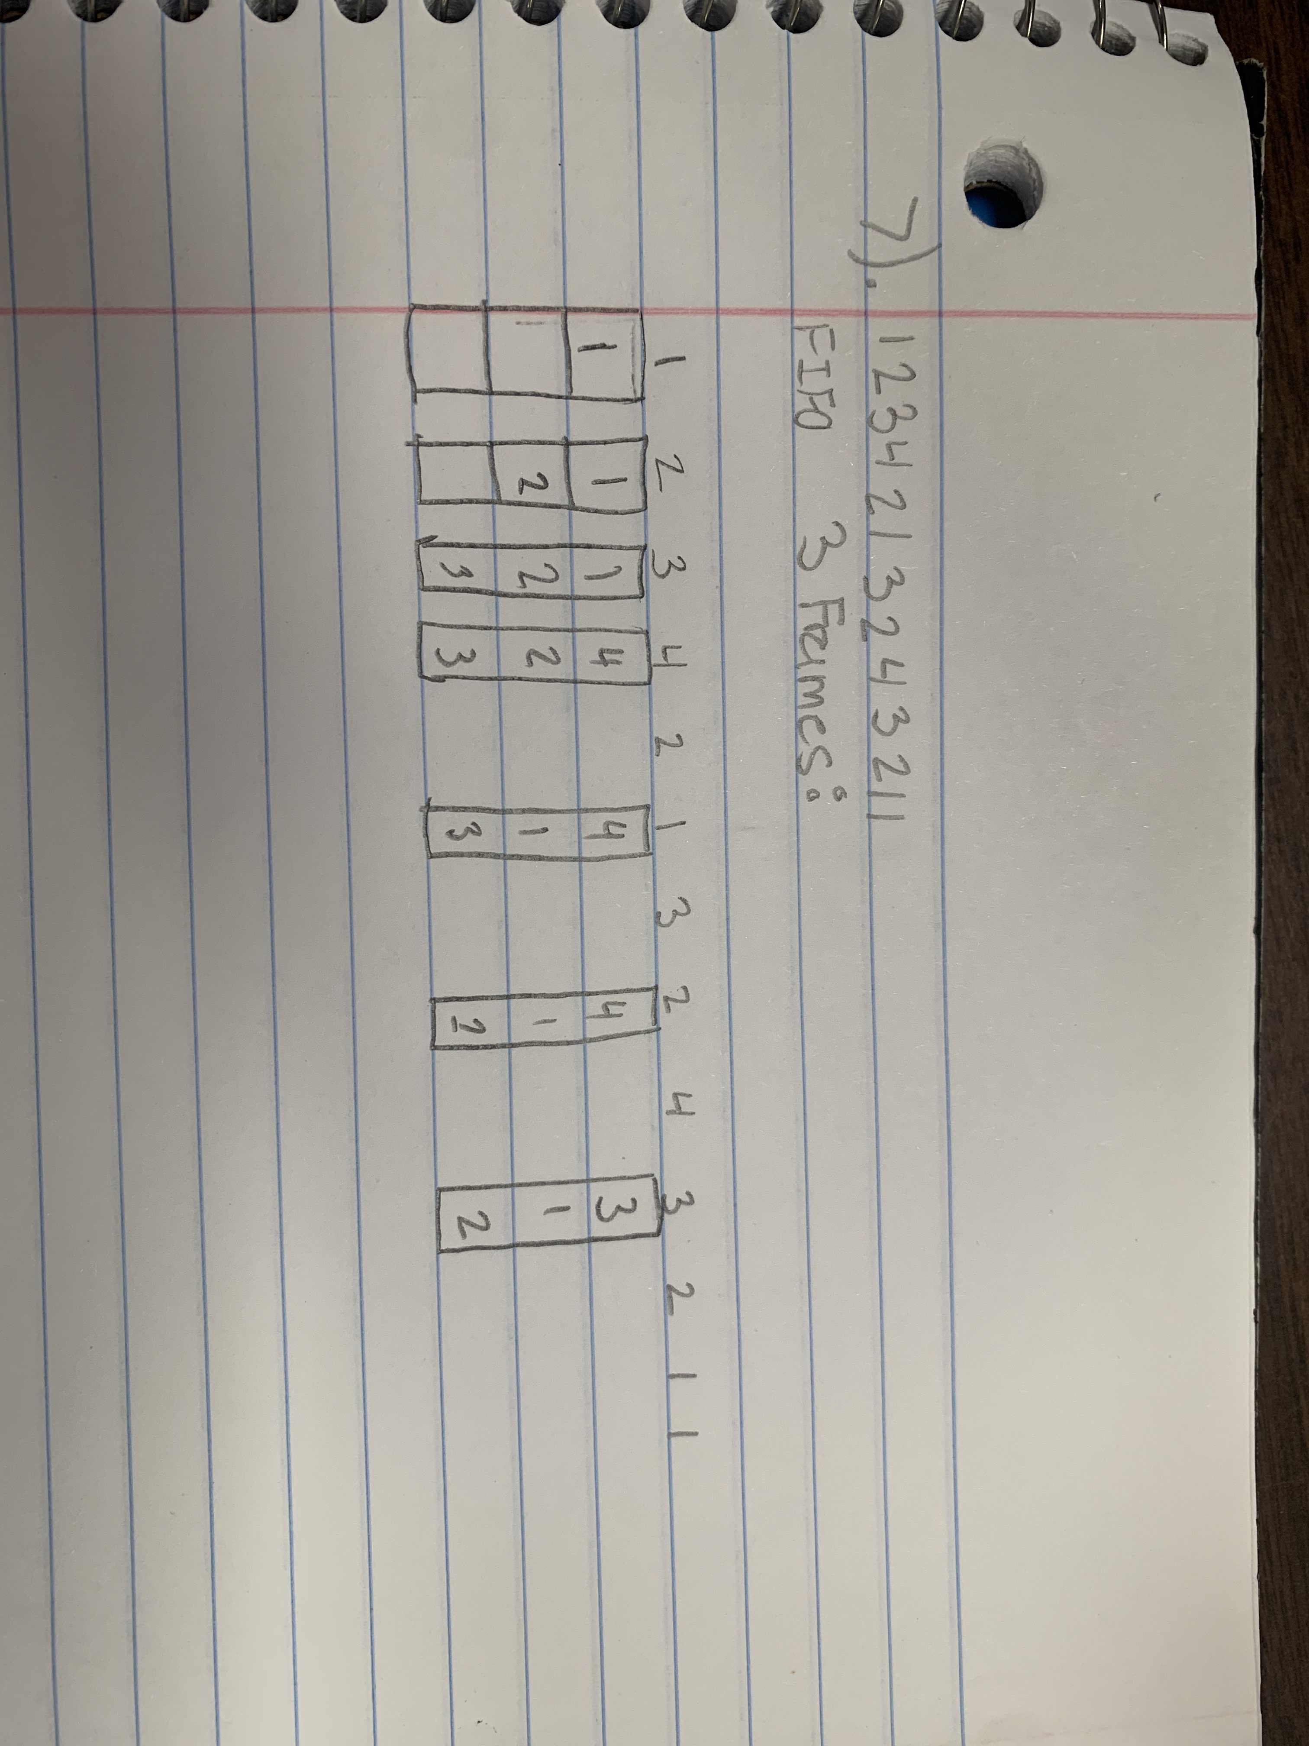

 Given that the system has 3 frames, using **FIFO** replacement algorithm. Please show the contents of the frames after each reference. Also be sure to indicate the final configuration of the three frames following the execution of the given reference string?

8.     (10 points) Please describe the MFU page-replacement algorithm. In addition, describe a major problem with this algorithm: The Most Frequently Used page-replacement algorithm replaces the page in memory that has been accessed the least frequently when a page fault occurs. It uses access counters to track page access frequency. However, a major problem with MFU is its sensitivity to changes in temporal locality, leading to suboptimal page replacement decisions in dynamic environments where access patterns fluctuate.

9.     (10 points) The **buddy system** allocates memory from a fixed-size segment consisting of physically contiguous pages. Suppose the memory segment is initially 128 KB and the kernel requests 15 KB of memory. Please draw a figure to represent the **buddy system** allocation:

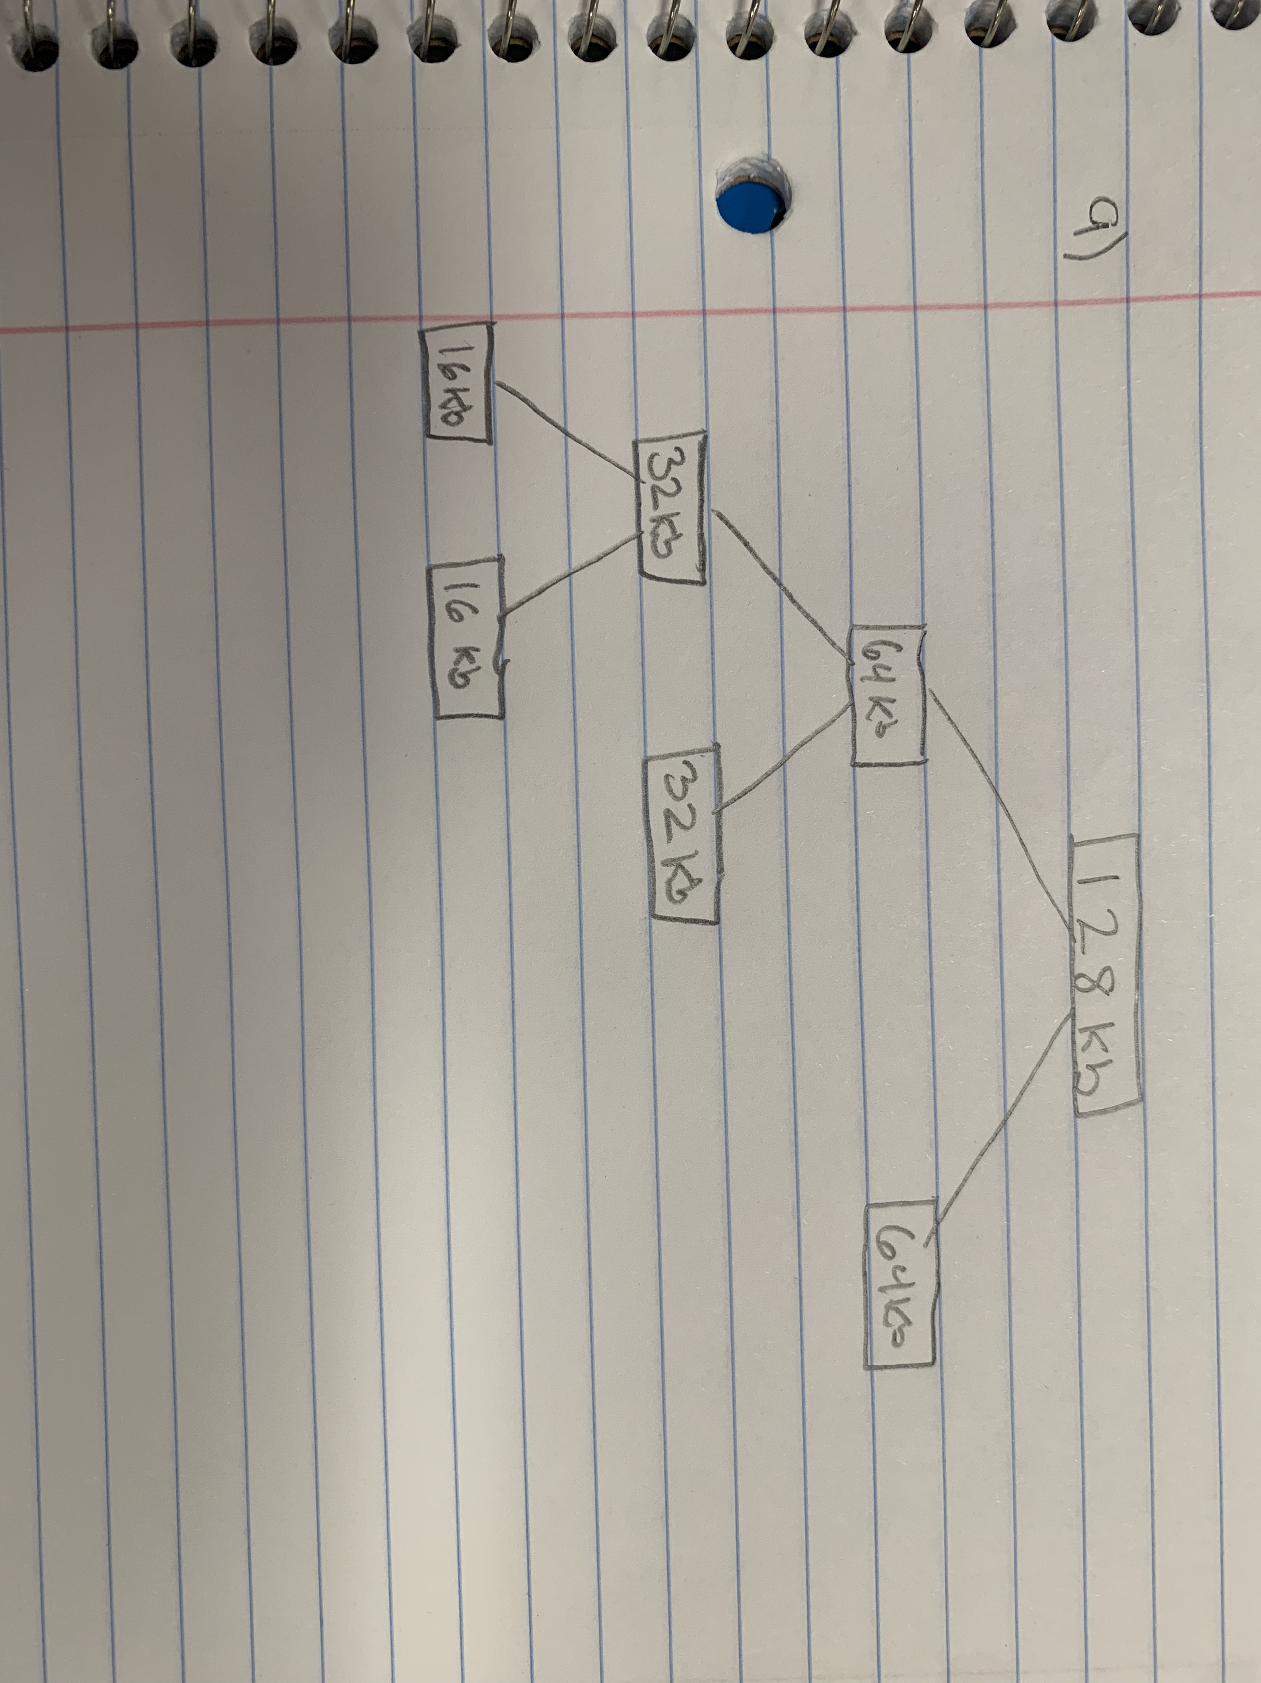

10.     (10 points) What is constant angular velocity in relation to disk drives?

Constant Angular Velocity in disk drives refers to a method where the disk rotates at a constant speed, maintaining a consistent angular velocity. This results in higher data transfer rates on outer tracks compared to inner tracks, simplifying the design but potentially leading to higher average seek times. CAV is a rotational speed approach used in storage devices like hard disk drives and optical disc drives.

11.  (10 points) Suppose that the disk queue holds requests for I/O blocks on cylinders 9, 8, 5, 1, 2, 7, 4, 5. Using FCFS and assuming that the disk head is at cylinder 1, what order will the cylinders be serviced? Assume that cylinder one was first placed into the queue.

1 9 8 5 1 2 7 4 5

12.  (10 points) Suppose the disk needed to service the following cylinders: 1 9 4 5 3. Using the SCAN scheduling algorithm, noting that the current head position is at 6 and that the head is moving towards 9, what is the order of servicing?

9 4 3 1 5

 13.  (10 points) Explain the terms seek time, rotational latency, and bandwidth.

Seek Time:

1. Definition: Time to position the read/write head. o Importance: Affects latency in accessing data.

Rotational Latency:

1. Definition: Time for desired data to rotate under the head.
2. Importance: Influenced by disk rotational speed; lower latency means faster access.

Bandwidth:

1. Definition: Data transfer rate between storage and computer.
2. Importance: Higher bandwidth allows faster reading and writing of data, influenced by disk speed and transfer protocols.